 Barb Larson Memorial Scholarship

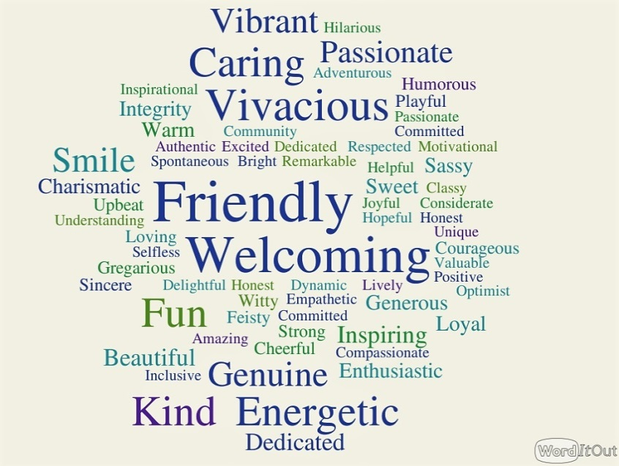

|  |
| --- |
| The Barb Larson Memorial Scholarship will be awarded to the candidate that most exemplifies the traits we so admire in our friend and colleague. Her top Strength Finder top traits are:  *Empathy – Achiever – Positivity – Responsibility - Relator*  The scholarship covers the full tuition for the class year..  The successful candidate will be responsible for all other obligations of the program including participation and attendance.  Application:  Name:__________________________________________________  Phone: ______________________E-mail: _____________________  Employer________________________________________________  Submit a brief statement choosing one of the two options below.   * Describe how you possess the traits of:   *Empathy –Achiever –Positivity –Responsibility –Relator*   * Describe how you exemplify the traits shown in the word cloud below |

The selection is the responsibility of the

Faribault’s Future Coordinator and Facilitator.

Deadline for applications is June 1, 2023

The Award will be announced in August

2023-2024 – Y5/5